6. Apply inline,internal ,and exteranal CSS styles to HTML elements.
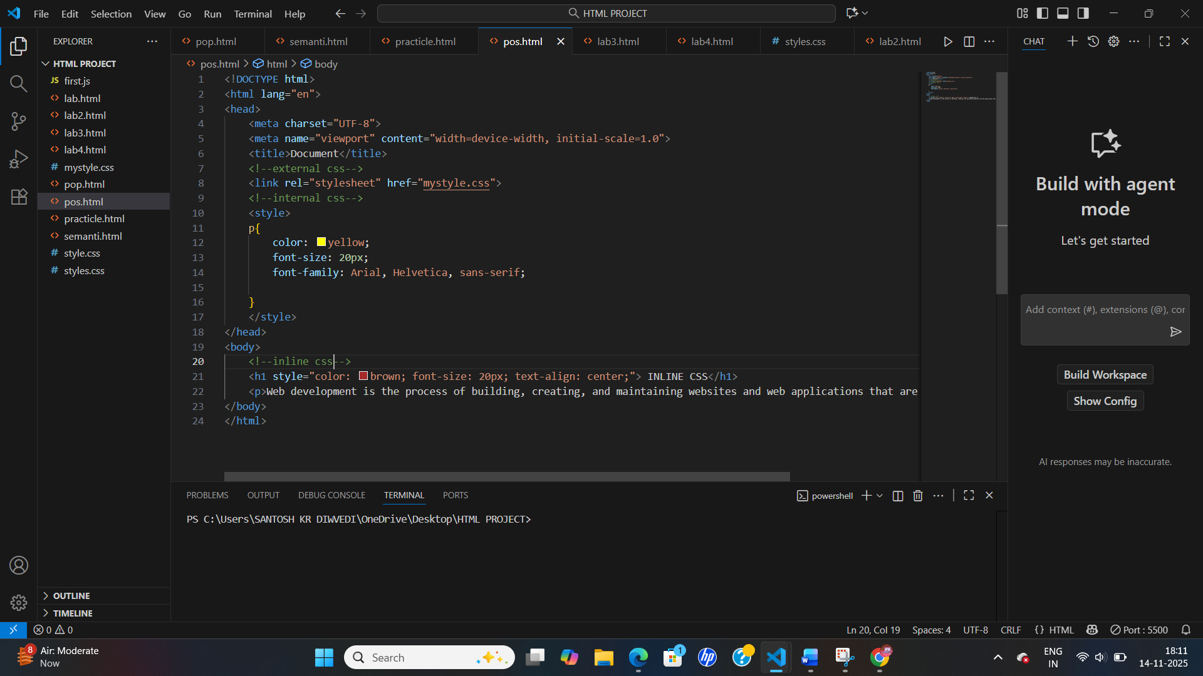
Output-
